Chapter 3: Theoretical Framework Construction

3.1 Motivation-Interaction Dual-Driven Gamified Learning Model (MID-GLM)
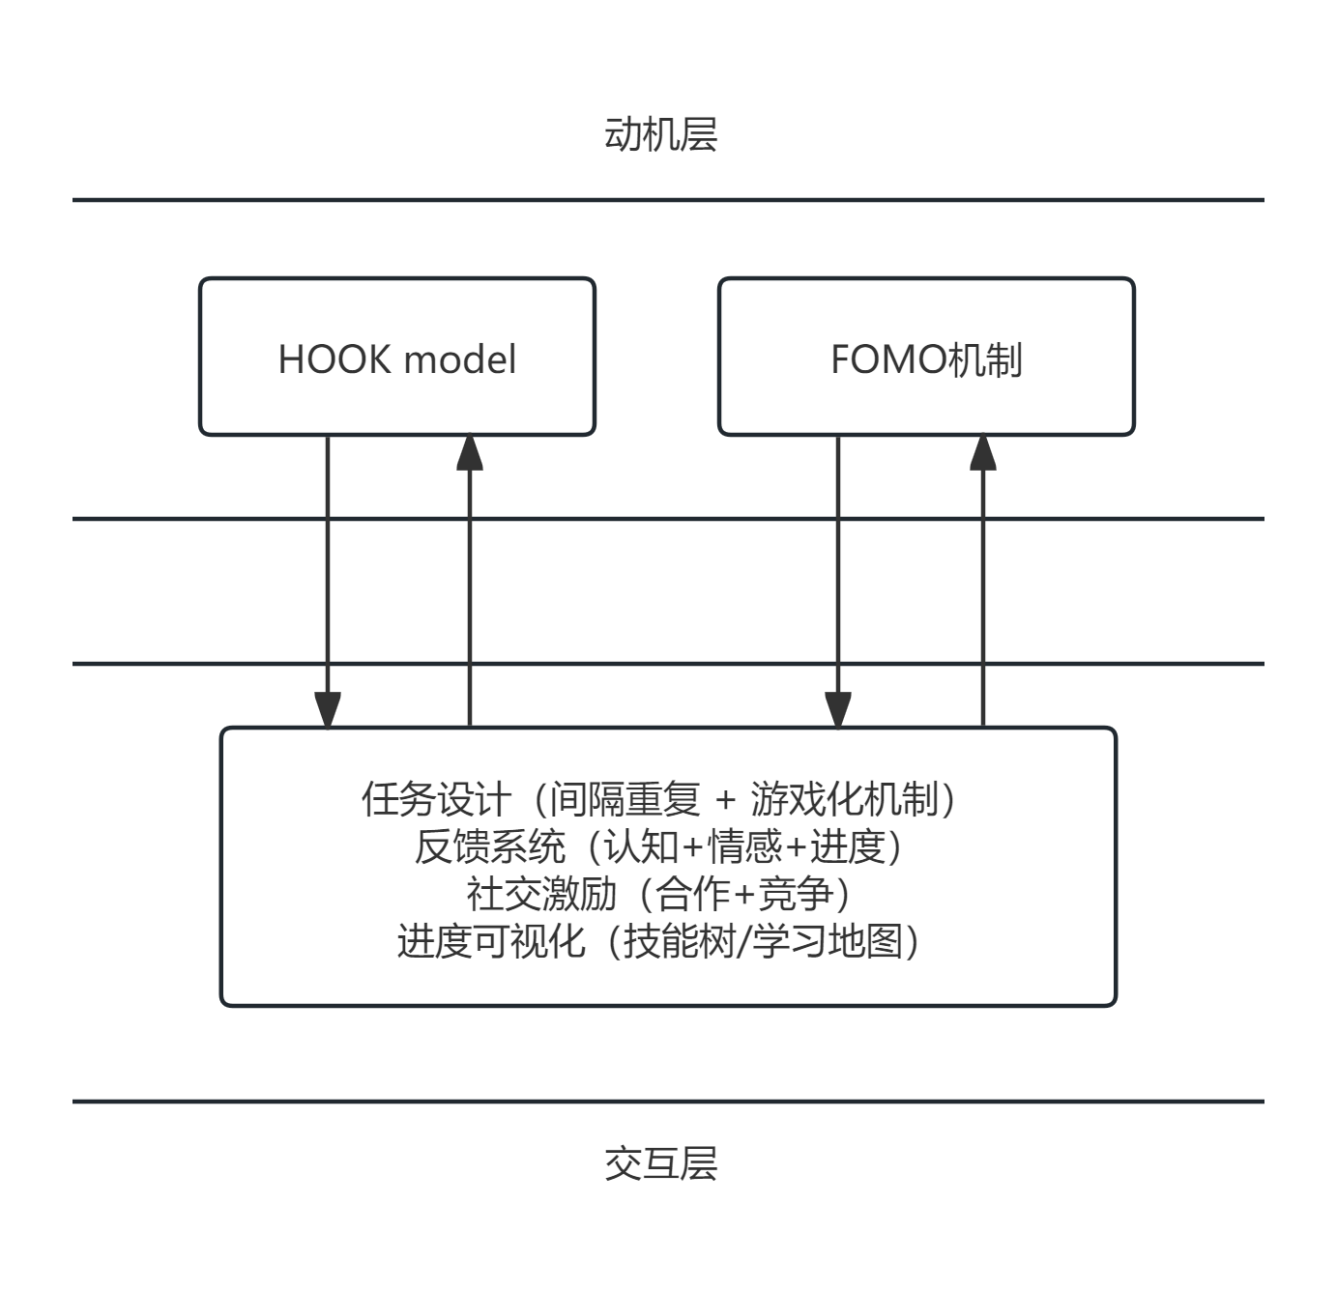
In contemporary educational practice, gamified learning has become a popular trend, aimed at enhancing learners' engagement and motivation through game elements. However, many applications often fall into two common pitfalls: On one hand, they overly rely on superficial game components, such as badges, leaderboards, and point systems, while neglecting the underlying psychological mechanisms that drive learners' sustained engagement. This results in shallow designs that prioritize "form over mechanism." On the other hand, gamified activities are disconnected from deep-level learning objectives and cognitive processes, leading to a "disconnect between motivation and cognition." Students may experience momentary enjoyment in activities but fail to achieve substantive knowledge construction or skill development. These flaws not only diminish the potential value of gamified learning but may also cause learner burnout or frustration. To address these issues, this study constructs the "Motivation-Interaction Dual-Driven Gamified Learning Model" (MID-GLM). The model is rooted in behavioral psychology (e.g., operant conditioning and habit formation theories) and cognitive science (e.g., cognitive load theory and constructivist learning theory). Its core argument is that merely stimulating learning motivation without guiding learners toward effective learning interactions will result in shallow engagement and temporary involvement. Conversely, well-designed learning interactions lacking sustained motivational drivers may struggle to initiate and maintain learners' active exploration. Therefore, the MID-GLM emphasizes that the motivation layer and interaction layer must operate as dual drivers, working synergistically to guide learners through a complete cycle: from "capturing attention" (motivation initiation) to "facilitating memory and understanding" (interaction deepening) and finally to "forming stable learning habits" (internalization and automation). This aims to achieve efficient and lasting learning outcomes.

The structure of the MID-GLM is illustrated in the accompanying diagram, featuring a dual-loop design: the central "learning loop" is surrounded by an outer "motivation layer" and an inner "interaction layer," with bidirectional arrows connecting the two layers, symbolizing dynamic interaction and mutual reinforcement. This design not only highlights the model's holistic nature but also emphasizes the inseparability of motivation and interaction in driving the learning process. The motivation layer serves as the external engine of the model, responsible for dynamically sustaining learning drive. It integrates the internalized application of the Hook Model and the positive guidance of the FOMO mechanism, aiming to trigger, maintain, and reinforce learners' willingness to participate. For instance, the Hook Model uses external triggers (e.g., push notifications or teacher reminders) and internal triggers (e.g., curiosity or problem-solving needs) to guide learners into the context. It then maintains interest by lowering the barrier to action and providing variable rewards (e.g., social recognition or random incentives), ultimately encouraging learners to invest time or emotion, forming a continuous cycle. Simultaneously, the FOMO mechanism is transformed into positive motivation, leveraging time-limited challenges or progress visualization to stimulate learners' social comparison tendencies, prompting active participation to avoid falling behind. The goal of the motivation layer is not only to get learners to "start" learning but also to use dynamic motivational strategies to make them "want to keep going," paving the way for deeper learning interactions.

The interaction layer, as the internal core of the model, focuses on constructing a closed loop of effective learning experiences, ensuring that once learners are drawn in by motivation, they engage in substantive cognitive processing and knowledge construction. This layer emphasizes clear task structures, breaking down learning content into progressively challenging tasks that follow the "zone of proximal development" theory. The difficulty level spirals upward, avoiding frustration while consistently delivering the joy of challenge, akin to "main quests" and "side quests" in games. Additionally, the interaction layer incorporates timely and multidimensional feedback mechanisms, including immediate feedback to reduce uncertainty, formative feedback to foster cognitive development, and diverse feedback forms (e.g., system, social, and intrinsic feedback), helping learners continuously adjust their strategies. Embedded social support, through collaborative tasks or knowledge-sharing communities, transforms learning from an individual activity into a social construction process, enhancing a sense of belonging and emotional support. Moreover, tools for visible progress and goal perception (e.g., experience bars or learning dashboards) make learners' growth tangible, providing not only a sense of achievement but also supporting metacognitive monitoring and helping learners identify next steps. The design goal of the interaction layer is to create a supportive, challenging, and feedback-rich environment, ensuring that learners, driven by high motivation, can engage in deep and effective learning.

The synergistic logic between the motivation layer and interaction layer is key to the success of the MID-GLM. The two layers do not exist in isolation but form a tightly coupled, mutually reinforcing dynamic system. The motivation layer directs traffic and empowers the interaction layer: Through the Hook Model and FOMO mechanism, it successfully captures learners' attention and sparks initial willingness to act, allowing the meticulously designed interaction layer to be experienced by learners. Without the drive of the motivation layer, the interaction layer might be "deserted," as learners lack the impetus to start and sustain participation. Conversely, the interaction layer provides value and meaning for the motivation layer: Sustained learning motivation is not maintained solely by external rewards but stems from the sense of competence, autonomy, and relatedness gained during the learning process. A well-designed interaction layer continually nourishes and reinforces learners' intrinsic motivation through the sense of mastery from completing tasks, the sense of progress from effective feedback, and the sense of connection from social interactions. Without the substantive learning experiences and positive emotional rewards provided by the interaction layer, extrinsic motivation (e.g., points or badges) would quickly lose its effectiveness, and the FOMO mechanism could turn into anxiety rather than positive engagement.

In summary, the MID-GLM model, through the synergistic drive of the motivation layer and interaction layer, aims to achieve the ultimate goal of gamified learning: making learning as captivating and productive as a well-designed game. The model not only addresses the pitfalls in current practice but also provides educators with an actionable framework to guide learners toward autonomous, efficient, and enjoyable lifelong learning. Through this dual-driven approach, the MID-GLM has the potential to promote deep learning internalization and habit formation in diverse educational environments, ultimately enhancing the overall quality of education.

3.2 Motivational Layer: Synergistic Drive of Hook Model and FOMO
As the external engine of the MID-GLM model, the motivation layer aims to address the key question of "why students are willing to participate continuously." By integrating the dual psychological drivers of the Hook Model and the FOMO mechanism, it constructs stable behavioral inertia, ensuring that learners transition from initial participation to long-term engagement. This design is rooted in principles of behavioral psychology, aiming to transform learning activities into a predictable and self-reinforcing habit loop, thereby overcoming the common issue of motivation decay in traditional gamified learning.

Specifically, the Hook Model draws from Eyal's theoretical framework, systematizing learning behavior into a cyclically reinforcing process: First, multiple triggers (such as smart push notifications like "You have 3 new words to review," teacher reminders, or fixed-time arrangements like daily morning reading) guide learners into the context, effectively leveraging external and internal stimuli to initiate action. Second, the action phase follows the principle of the "minimum viable action," designing low-threshold tasks (e.g., "complete 5 word matches") to significantly reduce cognitive and operational burdens, enabling learners to take the first step easily. Next, the variable reward mechanism provides unpredictable positive feedback (such as randomly unlocking achievement badges, obtaining virtual items, or receiving peer likes), activating the brain's dopamine system to enhance behavioral stickiness and exploratory desire. Finally, the investment phase encourages learners to commit resources to the system (e.g., customizing avatars in personalized learning spaces, building a collection of incorrect words, or accumulating points to redeem learning resources). These sunk costs not only increase user retention but also lay the groundwork for subsequent triggers, forming a self-reinforcing habit loop. Through this series of designs, the Hook Model not only stimulates short-term engagement but also cultivates long-term learning habits, shifting learners from passive responses to active returns.

Simultaneously, the FOMO (Fear of Missing Out) mechanism is introduced as another core component of the motivation layer. Targeting adolescents' strong need for group belonging and social recognition, it leverages carefully designed social comparison elements to stimulate participation. For instance, time-limited challenges (e.g., "Today's test sprint ends in 2 hours") create a sense of scarcity and urgency, prompting learners to act quickly. Real-time leaderboards and class progress heatmaps (e.g., "80% of the class has completed this, and you are 3 spots behind") utilize competitive instincts and herd mentality to motivate learners to catch up with their peers. Friend activity notifications (e.g., "Your desk mate just unlocked the 'Vocabulary Master' badge") further trigger imitation and competitive behavior, transforming social pressure into positive learning motivation. It is worth noting that in the MID-GLM model, FOMO is not intended to induce anxiety but serves as a catalyst for short-term engagement. It forms a strategic complement to the Hook Model's long-term habit cultivation: the FOMO mechanism drives learners' "first click" and quick response through immediate stimuli, while the Hook Model facilitates the "Nth return" and sustained engagement through cyclical reinforcement. This synergistic approach not only optimizes the dynamic balance of the motivation layer but also ensures that learners gradually internalize learning behaviors under high engagement, ultimately achieving a natural transition from extrinsic motivation to intrinsic drive. This provides a solid foundation for the deep learning experiences facilitated by the interaction layer.

3.3 Interaction Layer: Core Mechanism Supporting Deep Learning
In the MID-GLM model, the interaction layer serves as the internal core, aiming to address the critical question of "how to ensure students truly learn while participating." By integrating four meticulously designed mechanisms, it deeply aligns game elements with cognitive principles, ensuring that learners engage in effective knowledge construction and skill development under high motivation. The interaction layer focuses not only on learners' external behaviors but also emphasizes internal cognitive processes, such as memory, understanding, and metacognitive monitoring, thereby avoiding the common pitfall of "playing without learning" in traditional gamified approaches. By combining task design, feedback systems, social incentives, and progress visualization, the interaction layer creates a supportive, challenging, and feedback-rich learning environment. This enables learners to transition from superficial participation to deep processing, ultimately achieving lasting internalization and application of knowledge. The design of this layer is rooted in cognitive science theories, emphasizing that learning activities must align with the human brain's information processing mechanisms to maximize learning outcomes.

First, the task design mechanism, based on the Ebbinghaus forgetting curve, constructs spaced repetition task flows to optimize memory retention and knowledge consolidation. Learning tasks are not randomly assembled; instead, they adopt diverse formats, such as integrating classroom Q&A, group challenges, and practice-quiz (PQ) tasks, to avoid cognitive fatigue from mechanical repetition. Game narrative elements like "level unlocking" or "chapter progression" are embedded to imbue learning activities with a sense of story and purpose. For example, in vocabulary learning, learners might unlock new themes by completing a series of "levels." This not only enhances task engagement but also ensures gradually increasing difficulty through progressive challenge design, aligned with the "zone of proximal development" theory. Such a structure maintains learners' interest while fostering cognitive growth. This task framework transforms learning into a predictable and self-reinforcing journey, shifting learners from passive information reception to active exploration and knowledge integration.

Second, the feedback system mechanism moves beyond simplistic "right/wrong" evaluations by adopting immediate, specific, and growth-oriented multidimensional feedback to promote learners' cognitive development and self-regulation. Cognitive feedback focuses on the understanding and application of knowledge rather than mere memorization. For instance, in PQ tests, the system provides correct answers and detailed explanations for specific questions, helping learners grasp underlying principles rather than surface errors. Affective feedback reinforces learners' self-efficacy through encouraging language, stimulating intrinsic motivation and positive emotions. Additionally, progress feedback utilizes visualization tools to display learning trajectories, enabling learners to intuitively perceive their advancements and areas for improvement, thereby facilitating metacognitive monitoring and adjustment. This feedback system not only corrects errors but also supports holistic learner development through diverse information inputs (including system, social, and intrinsic feedback), ensuring that feedback serves not only as information transmission but also as emotional support and a catalyst for growth.

Third, the social incentive mechanism transforms learning from an isolated activity into a social construction process by integrating collaborative and competitive community designs, enhancing learners' sense of belonging and persistence. For example, the system includes group collaboration tasks, such as "team-based completion of knowledge maps," encouraging learners to solve problems through discussion, sharing, and mutual assistance. This not only deepens knowledge understanding but also cultivates teamwork skills. Simultaneously, functions like peer reviews and learning check-in sharing introduce moderate competitive elements, such as real-time leaderboards or achievement displays, fostering healthy comparison and emulation among learners. Research shows that such social interactions significantly enhance learning persistence and emotional belonging, as they address fundamental psychological needs like relatedness and competence. Through embedded social support, the interaction layer not only leverages adolescents' desire for group identity but also integrates the learning experience into daily life, allowing learners to derive emotional rewards from interactions and sustain long-term engagement.

Fourth, the progress visualization mechanism employs tools such as "learning journey maps," "skill tree lighting," or "weekly achievement walls" to make abstract learning processes tangible, enhancing learners' sense of purpose and control. These visual designs help learners clearly see "how far they've come" and "what remains to be done," thereby boosting goal commitment and self-regulation abilities. For instance, in vocabulary learning, a "skill tree" might display mastery levels across different word categories, with learners "lighting up" branches by completing tasks, providing an intuitive sense of knowledge expansion. Meanwhile, a "weekly achievement wall" summarizes weekly progress, offering summative feedback and motivating learners to set new goals. This mechanism not only complements the reward system of the motivation layer but also supports learners' metacognitive development, enabling them to autonomously monitor progress, adjust strategies, and derive a sense of accomplishment and intrinsic motivation.

In summary, the interaction layer, through the synergistic operation of task design, feedback systems, social incentives, and progress visualization, constructs a comprehensive core framework for supporting deep learning. These mechanisms not only reinforce one another but also dynamically couple with the motivation layer, ensuring that learners engage in effective cognitive processing and knowledge internalization under high engagement. For example, task design provides a structured learning path, the feedback system ensures timely corrections, social incentives add an emotional dimension, and progress visualization reinforces goal orientation. This integrated design enables the MID-GLM model to achieve the ultimate goal of gamified learning: making learning both engaging and productive, ultimately guiding learners toward autonomous, efficient, and enjoyable lifelong learning. Through the meticulous implementation of the interaction layer, learners can not only acquire substantive knowledge but also develop sustainable learning habits and capabilities.

Eyal, N. (2014). Hooked: How to build habit-forming products. Portfolio.

